Internship Registration API — Feature Documentation

Overview
The Internship Registration API delivers 11 features through 59 REST endpoints. Students (or cyber cafés on their behalf) register, verify their email, upload a consent letter, pay the fee online and receive an acceptance letter and a WhatsApp group link.
Tech stack: Spring Boot 3.3.4, Java 21, Spring Security with JWT, Spring Data JPA, MySQL / TiDB, Razorpay Java SDK, Gmail SMTP (Spring Mail), Lombok, Maven.
Roles
Role | What it can do
SUPER_ADMIN | Manages master data, consent reviews, WhatsApp groups, acceptance letter search, admin user creation
UNIVERSITY_ADMIN | Treated as an admin when viewing students, registrations, consent letters, payments and letters
STUDENT | Registers, verifies email, uploads consent, pays, views own profile, letter and group link
CYBER_CAFE | Registers students and acts on their behalf for consent, payment and letters
Features at a glance
# | Feature | Endpoints
1 | Login and JWT security | 1
2 | Student registration | 1
3 | Cyber café registration | 1
4 | Email OTP: verification and password reset | 4
5 | Master data management | 30
6 | Student profile | 2
7 | Consent letter workflow | 5
8 | Razorpay payment | 3
9 | Acceptance letter | 4
10 | WhatsApp group management and notifications | 7
11 | University admin creation | 1
 | Total | 59

Setup and configuration
The app runs on port 8080 and reads its secrets from environment variables or a local .env file in the project root.
./mvnw spring-boot:run
Variable | Purpose | Required
DB_URL, DB_USERNAME, DB_PASSWORD | MySQL / TiDB connection | Yes
JWT_SECRET | Base64 signing key (openssl rand -base64 64) | Yes
RAZORPAY_KEY_ID, RAZORPAY_KEY_SECRET, RAZORPAY_WEBHOOK_SECRET | Razorpay credentials | Yes
MAIL_USERNAME, MAIL_PASSWORD | Gmail SMTP login (Google App Password) | Password needed to send mail
APP_UPLOAD_DIR (app.upload.dir) | Folder for uploaded consent letters, default ./uploads | No
app.upload.max-size-mb | Upload size limit, default 5 MB | No
app.admin.notify-email | Admin address told when a WhatsApp group is needed | No
Built-in rules (application.properties)
Setting | Value
JWT lifetime | 24 hours
OTP expiry | 10 minutes
OTP wrong attempts allowed | 5
OTP resend cooldown | 60 seconds
OTP emails per hour | 5
Hibernate schema mode | validate (tables must already exist)
Sender | noreply@ficusglobal.com, "Ficus Internship Portal"

Features

1. Login and JWT security
- One login for all roles, using email or mobile number plus password.
- Passwords hashed with BCrypt; JWT signed with HS256, valid 24 hours, user ID stored as the subject.
- Same "Invalid credentials" message for unknown user and wrong password, so accounts can't be probed.
- Disabled accounts are refused at login; last login time is recorded.
- Stateless sessions, CORS configured for localhost and deployed frontends.
- Global error handler returns clean JSON errors for about 22 exception types (validation, 404, 409, 403, upload size and more).

2. Student registration
- One call creates the login account, the student's academic profile and an internship registration.
- Collects name, email, 10-digit mobile, password, father's name, gender, college, degree, department, academic session, university registration number, college roll number and major subject.
- Fee is taken from the selected batch; inactive batches are refused.
- Terms of Service must be accepted; duplicate email or mobile is refused.
- A verification OTP is emailed right after signup. A mail failure never cancels the registration.

3. Cyber café registration
- A café signs up with shop name, owner name, address, email, mobile and password.
- When a logged-in café registers a student, the registration is linked to that café.
- The café can then view that student's profile and handle consent upload, payment and the acceptance letter for them.

4. Email OTP: verification and password reset
- 6-digit codes from a secure random generator, stored hashed, single use.
- Valid 10 minutes, 5 wrong attempts before the code is burned.
- 60-second resend cooldown and a cap of 5 codes per hour per user.
- Responses are identical whether or not the email exists.
- Emails go out in the background, only after the code is saved.
- Password reset also marks the email as verified.

5. Master data management
- Five tables: universities, districts, colleges, internship courses, internship batches.
- 5 public dropdown endpoints: active universities, districts, colleges filtered by university and district, active courses, active batches of a course.
- 25 SUPER_ADMIN endpoints: list, get, create, update and delete for each table.
- Duplicates return HTTP 409, ignoring case and surrounding spaces: university name and code, district name, college name within the same university and district, college code.
- A record still in use can't be deleted (for example a college with students, a batch with registrations or a WhatsApp group); the message suggests deactivating instead.
- Batches carry start and end dates, registration window, fee, maximum students, status and active flag; end date can't be before start date.
- Courses carry theory, practical, report-preparation and total hours.

6. Student profile
- GET /api/student/me returns the logged-in student's full details: personal info, college with address, latest registration, batch and course.
- GET /api/student/{id} accepts a student ID or user ID. Allowed for the student, the café that registered them, or an admin.

7. Consent letter workflow
- Upload a PDF, JPG or PNG of up to 5 MB. The type is detected from the file contents, and the file gets a generated name.
- Files are stored outside the web root and served only through the API.
- A new upload resets the status to PENDING and clears any earlier rejection; the old file is deleted afterwards.
- An approved letter can't be replaced by the student.
- Students see the status (PENDING, APPROVED, REJECTED) and the rejection reason, and can download the file.
- Admins list consents (optionally by status) and approve or reject. A rejection needs a reason of up to 500 characters.

8. Razorpay payment
- Create order is allowed only after the student's email is verified and a consent letter is uploaded and not rejected.
- Paid, in-progress, completed or cancelled registrations can't be paid again.
- Amount comes from the registration's payable amount (the batch fee), sent to Razorpay in paise.
- Verify checks the Razorpay signature and that the order belongs to the registration.
- The webhook checks its HMAC signature and handles payment.captured and payment.failed.
- On success the registration becomes ENROLLED and a confirmation email is sent after the payment is saved.

9. Acceptance letter
- Generated only once payment is confirmed (ENROLLED, IN_PROGRESS or COMPLETED).
- Number format FG/<COLLEGE_CODE>/<SESSION>/<SERIAL>, for example FG/GPM/2024-2027/1. The serial starts at 1 for each college and session.
- Generating again returns the same letter; parallel requests are handled with a retry.
- The response carries everything needed to print: letter number, student, college with address and district, university, batch dates, course and hours.
- Students fetch their own letter; admins search by college code and session.

10. WhatsApp group management and notifications
- One group per college and batch, managed by SUPER_ADMIN with 5 CRUD endpoints. Only https://chat.whatsapp.com/ invite links are accepted.
- The payment success email includes the group link when a group exists.
- If no group exists yet, the student is told the link will follow, and the admin is emailed once per batch.
- The admin can email the link to all paid students still waiting, or resend it to everyone.
- A paid student can fetch the group link from the API.

11. University admin creation
- SUPER_ADMIN can create a UNIVERSITY_ADMIN account with name, email, mobile and password.

Student journey
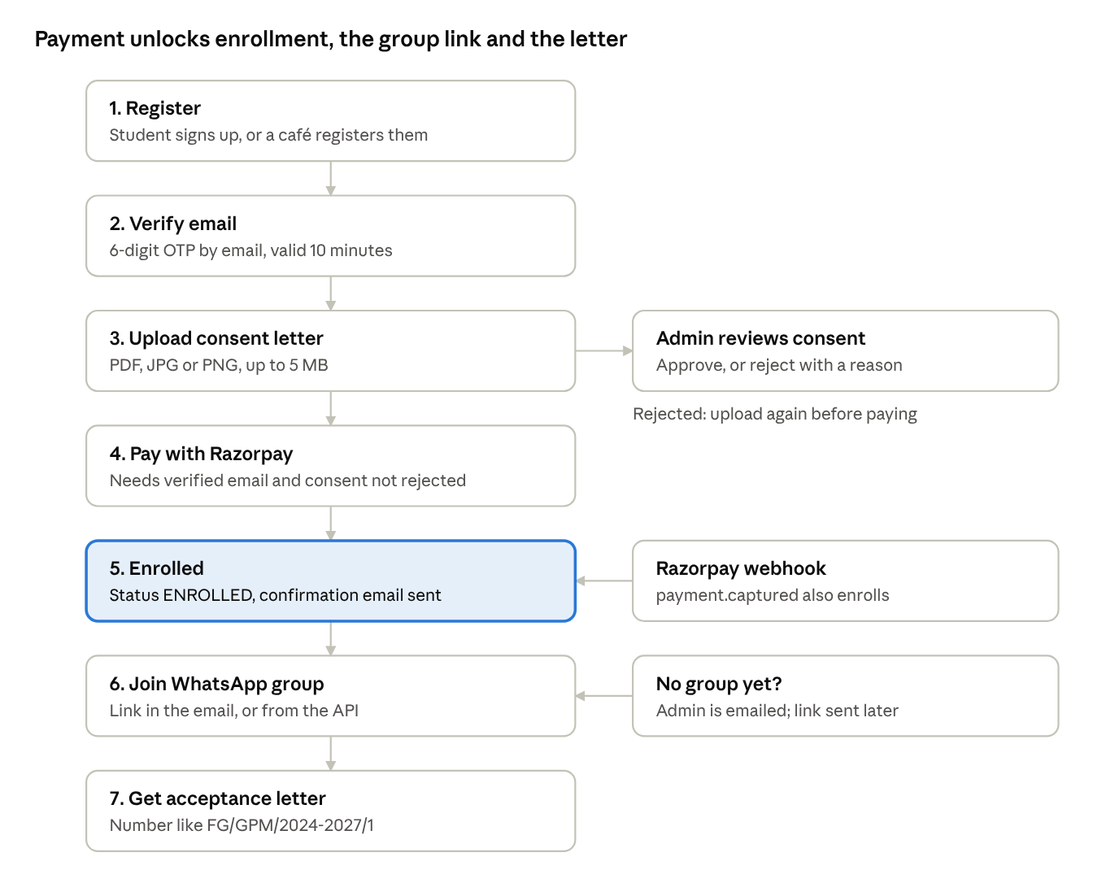
student journey · 7 steps
A cyber café can perform every step on the student's behalf. Steps 6 and 7 open only after the payment is confirmed.

API endpoint reference
All 59 endpoints, grouped by module. "Login" means any valid JWT; owner means the student, the café that registered them, or an admin.
Auth and OTP (public) — 7
Method | Path | Purpose
POST | /api/auth/login | Login with email or mobile
POST | /api/auth/register/student | Register a student
POST | /api/auth/register/cybercafe | Register a cyber café
POST | /api/auth/email/send-otp | Send email verification code
POST | /api/auth/email/verify-otp | Verify email with code
POST | /api/auth/password/forgot | Send password reset code
POST | /api/auth/password/reset | Reset password with code
Master data dropdowns (public) — 5
Method | Path | Purpose
GET | /api/public/master/universities | Active universities
GET | /api/public/master/districts | All districts
GET | /api/public/master/colleges?universityId=&districtId= | Colleges for a university and district
GET | /api/public/master/courses | Active courses
GET | /api/public/master/batches?courseId= | Active batches of a course
Master data admin (SUPER_ADMIN) — 25
The same five endpoints exist for each of universities, districts, colleges, courses and batches under /api/admin/master/:
Method | Path | Purpose
GET | /api/admin/master/{type} | List all (colleges filter by universityId, districtId; batches by courseId)
GET | /api/admin/master/{type}/{id} | Get one
POST | /api/admin/master/{type} | Create
PUT | /api/admin/master/{type}/{id} | Update
DELETE | /api/admin/master/{type}/{id} | Delete if not in use
Student — 2
Method | Path | Access
GET | /api/student/me | Login (student)
GET | /api/student/{id} | Self, registering café, admin
Consent letter — 5
Method | Path | Access
POST | /api/student/registrations/{registrationId}/consent (multipart file) | Owner
GET | /api/student/registrations/{registrationId}/consent/status | Owner
GET | /api/student/registrations/{registrationId}/consent (download) | Owner
GET | /api/admin/consents?status= | SUPER_ADMIN
PUT | /api/admin/registrations/{registrationId}/consent | SUPER_ADMIN
Payment — 3
Method | Path | Access
POST | /api/payment/create-order | Owner
POST | /api/payment/verify | Login
POST | /api/payment/webhook | Public, Razorpay signature
Acceptance letter — 4
Method | Path | Access
POST | /api/acceptance-letters/registrations/{registrationId} | Owner
GET | /api/acceptance-letters/registrations/{registrationId} | Owner
GET | /api/acceptance-letters/me | Login (student)
GET | /api/admin/acceptance-letters?collegeCode=&academicSession= | SUPER_ADMIN
WhatsApp groups — 7
Method | Path | Access
GET | /api/admin/whatsapp-groups?collegeId=&batchId= | SUPER_ADMIN
GET | /api/admin/whatsapp-groups/{id} | SUPER_ADMIN
POST | /api/admin/whatsapp-groups | SUPER_ADMIN
PUT | /api/admin/whatsapp-groups/{id} | SUPER_ADMIN
DELETE | /api/admin/whatsapp-groups/{id} | SUPER_ADMIN
POST | /api/admin/whatsapp-groups/{id}/send-pending?resend= | SUPER_ADMIN
GET | /api/student/registrations/{registrationId}/whatsapp-group | Owner, after payment
Admin users — 1
Method | Path | Access
POST | /api/admin/users/create | SUPER_ADMIN

Data model
Thirteen JPA entities map to existing tables; the schema is validated at startup, not created.
Entity | Table | Holds
User | users | Login account: name, email, mobile, password hash, role, active, email verified, last login
Student | students | Academic profile linked to a user: college, father's name, gender, degree, department, session, registration and roll numbers
CyberCafe | cyber_cafes | Shop name, owner, address, linked user
InternshipRegistration | internship_registrations | Student, optional café, batch, status, fees, consent file and review, WhatsApp link sent time
Payment | payments | Razorpay order, payment ID, signature, amount, status
StudentAcceptanceLetter | student_acceptance_letter | Letter number, college code, session, serial
University, District, College | universities, districts, colleges | Names, codes, address; college belongs to a university and district
InternshipCourse, InternshipBatch | internship_courses, internship_batches | Course hours; batch dates, fee, capacity, status
WhatsappGroup | whatsapp_groups | One invite link per college and batch
UserVerificationOtp | user_verification_otp | Hashed code, purpose, attempts, expiry, used time
Status values
Enum | Values
RegistrationStatus | REGISTERED, PAYMENT_PENDING, ENROLLED, IN_PROGRESS, COMPLETED, CANCELLED
ConsentStatus | PENDING, APPROVED, REJECTED
Role | SUPER_ADMIN, UNIVERSITY_ADMIN, STUDENT, CYBER_CAFE
OtpPurpose | EMAIL_VERIFICATION, PASSWORD_RESET
Gender | MALE, FEMALE, OTHER

